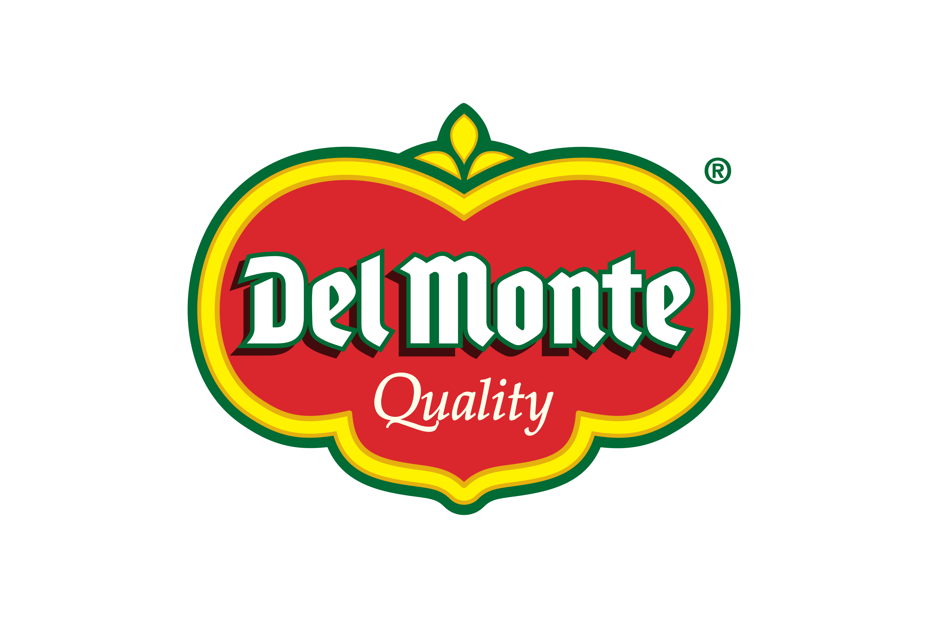
Del Monte Consumer Affairs
PO: 1225
Rancho Cordova, CA 95741

12/04/2025
«Consumer_Full_Name»
«Consumer_Street_Address»
«Consumer_City», «Consumer_State» «Consumer_ZIP_Code»
Dear «Consumer_Full_Name»,
Thank you for taking the time to contact us regarding your recent question or concern. We truly appreciate the opportunity to assist you and are glad we were able to resolve your inquiry to the best of our ability.
As a token of our appreciation, please enjoy your next round of Del Monte products on us with the refund check enclosed in the mail. We hope you continue to enjoy the quality and freshness you expect from Del Monte.
If you have any further questions or feedback, please don’t hesitate to reach out. We’re always happy to hear from you.
Warm regards,
The Del Monte Consumer Affairs
Del Monte Foods, Inc.

